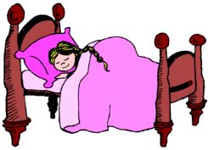
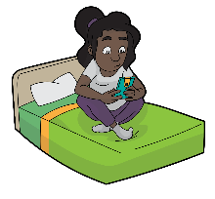
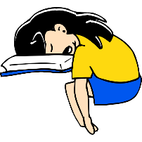
My Sleep Diary Experiment

 | Night 1 | Night 2 | Night 3 | Night 4
List the things you did before bed e.g. read, tablet, listen to music, take a shower etc. |  |  |  |  | Which routine worked the best?
Did you have trouble falling asleep? |  |  |  |  | What was stopping you from going asleep?
Did you wake up during the night? |  |  |  |  | What woke you?
How many hours sleep did you get? |  |  |  |  | What night did you have the most sleep?
How do you feel today? |  |  |  |  | Did the amount of sleep you got affect you the next day?
Are you tired during the day? |  |  |  |  | Did getting more sleep give you more energy/ help you concentrate?

- From the results of your sleep experiment, create a bedtime routine that will allow you to get enough sleep.
- List the effects of not getting enough sleep.

